Network Protocols & Communications (Part 1)

**Data communication**: Are the exchange of data between twıo nodes via some form of link (transmission medium) such as a cable.

**Data Flow:**

1. **Simplex**
   1. Communication is always unidirectional.
   2. One device can transmit and the other device will receive.
   3. Example: Keyboards, Traditional monitors.
2. **Half Duplex**
   1. Communication is in both directions but not at the same time.
   2. If one device is sending, the other can only receive, and vice versa.
   3. Example: Walkie-Talkies.
3. **Duplex (Full Duplex)**
   1. Communication is in both directions simultaneously.
   2. Devices can send and receive at the same time.
   3. Example: Telephone line.

**Protocols**:

All communication shecams will have the following things in common:

1. Source or sender
2. Destination or receiver
3. Channel or media

Rules or protocols govern all methods of communication.

Protocol = rule

It is a set of rules that govern data communication.

**Protocol determines:**

1. What is communicated?
2. How is it communicated?
3. When it is communicated?

**Protocols used in network communications also defined: (Elements of a protocol)**

1. Message encoding
2. Message formatting and encapsulation
3. Message timing
4. Message size
5. Message delivery options
6. **Message Encoding:**

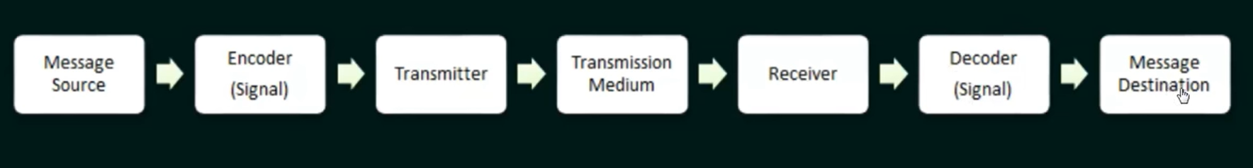

1. **Message formatting and encapsulation**

Agreed format.

Encapsulate the information to identify the sender and the receiver rightly. (Data will have source and destination info like the ip addresses)

1. **Message size**

Humans break long messages into smaller parts or sentences.

Long messages must also be broken into smaller pieces to travel across a network.

Big data will be participated into smaller data. And these smaller boxes will be numbered so that the receiver can reassemble the data without any loss or wrong information.

1. **Message timing**

Flow control

Response Timeout.

Assume we have 2 computers: one super fast, one super slow. When a fast one sends info very fast the slow one can't handle all the data that is coming in. It is the protocol's responsibility to have a flow control mechanism.

Another thing is the acknowledgment time. Slow one should send an acknowledgment too fast to say that it received the message. The fast one should have a timeout to wait to determine how long it should wait for the response.

Sender will be notified by the receiver of how long it takes for a certain data to be received According to that information the sender will send the ‘information in that t’me spectrum.

Also the sender will have a timeout for the acknowledgment message. If acknowledgement doesn't come in that time period, the data will be sent again to prevent data loss.

1. **Message Delivery Options**
   1. **Unicast**: One sender, one receiver
   2. **Multicast**: One sender, multiple receiver
   3. **Broadcast**: One sender, to all the participants in the network.